Referral Guidelines
headspace Albury Wodonga and headspace Wangaratta is a free, youth service for young people aged 12-25 years.
Together with Gateway Health as our lead agency and 10 local agencies, we offer the following supports and services:
- Youth Generalist Counsellors
- Alcohol and other Drug Support Counsellors
- Sexual Health Clinic
- Community engagement, education and awareness
- Access to support around housing
- Centrelink Support Services
- Dietician

- General Practitioner appointments with Gateway Health Medical Practice (one appointment is reserved exclusively for headspace each day)
- MBS (Under GP Mental Health Treatment Plans)
- Youth Workers Care Co-Ordination
- Education and Job Seeking support and information

PLEASE NOTE: headspace Albury Wodonga and headspace Wangaratta are not an acute mental health/crisis service. If you have any immediate concerns regarding the safety and wellbeing of a young person please contact one of the following services for assistance; Mental Health Triage Service 1300 104 211, Lifeline 13 11 14, Kids Helpline 1800 55 1800. If the individual you are referring is out of our age group please phone Head to Help on 1800 595 212.
In an emergency please call 000 immediately.
REFERRAL SOURCES
Self-referral – Young people are encouraged to make contact with headspace Albury Wodonga or headspace Wangaratta directly.
Family referral – Families, carers or friends can refer a young person to headspace Albury Wodonga or headspace Wangaratta. The young person needs to be aware of and consent to the referral and be willing to meet with a member from the headspace Albury Wodonga or headspace Wangaratta team.
By phone/email – 1300 332 022 speak to our duty worker or leave a message and we will call you within 2 business days, an answering service is available after hours. Email referrals can also be sent to headspaceAW@gatewayhealth.org.au or headspaceWangaratta@gatewayhealth.org.au. Please save the document as an encrypted PDF in word. It is best to ring through the password to ensure the young persons’ details remain confidential
Drop in – Young people can drop into the centre or site, check out our details at headspace.org.au/headspace-centres/albury-wodonga/ or headspace.org.au/headspace-centres/Wangaratta
Professional referral – General Practitioners, Allied Health Professionals and community based agencies and educational institutions can refer to headspace Albury Wodonga or headspace Wangaratta using the attached referral form.

headspace is proudly delivered in partnership with the following affiliates:

.

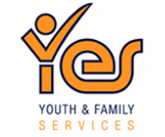

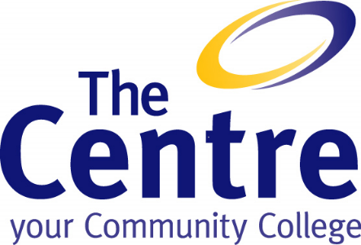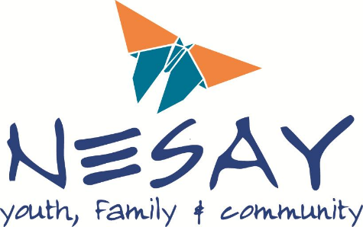

For additional information regarding headspace Albury Wodonga, please contact the centre directly on 1300 332 022 or visit our website headspace.org.au/alburywodonga or headspace.org.au/wangaratta

Referral Form
headspace Albury Wodonga is a voluntary service for young people aged 12-25 years of age. headspace can only engage with the young person if they have consented to the referral. Please ensure all sections are completed and legible.
Date of Referral:
Has the young person consented to the referral? |  |  |  |  |  |  |  |  |  |  |  |  |  |  |  |  |  |  | Yes |  | No
Is the young person aged 12-25 years of age? |  |  |  |  |  |  |  |  |  |  |  |  |  |  |  |  |  |  | Yes |  | No
Details of Young Person
If the young person is under 16 years of age, have the parents or carers of the young person consented to the referral? Please provide name and number of person consenting below |  |  |  |  |  |  |  |  |  |  |  |  |  |  |  |  |  |  | Yes |  | No
Surname |  |  |  |  |  |  |  | First Name
Gender |  |  |  |  |  |  |  | Preferred Pronoun
Date of Birth
Address
Suburb |  |  |  |  |  |  |  | Postcode
Phone (Home) |  |  |  |  |  |  |  | Mobile
Email |  |  |  |  |  |  |  | Preferred method of communication? |  |  |  |  |  | Phone (Home) |  |  |  | Email
Nationality |  |  |  |  |  |  |  |  |  |  |  |  |  | Mobile |  |  |  | SMS
Preferred Language |  |  |  |  |  |  |  | Interpreter Required? |  |  |  |  |  | Yes |  |  |  | No
Do you Identify as |  | Aboriginal |  |  |  |  | Torres Strait Islander |  |  |  | Aboriginal & Torres Strait Islander
Would you prefer an Albury Wodonga Aboriginal Health Service worker? |  |  |  |  |  |  |  |  |  |  |  |  |  |  |  |  |  |  | Yes |  | No
Emergency Contact
Name |  |  |  |  |  |  |  | Relationship to young person
Address
Suburb |  |  |  |  |  |  |  | Postcode
Phone (Home) |  |  |  |  |  |  |  | Mobile
Details of Referrer (please ensure this section is completed)
Name of Referrer |  |  |  |  |  |  |  |  |  | Organisation
Address
Suburb |  |  |  |  |  |  |  |  |  | Postcode
Phone (Business Hours) |  |  |  |  |  |  |  |  |  | Phone (Mobile)
Email |  |  |  |  |  |  |  |  |  | Relationship to young person
Reason/s for Referral
 | Wellbeing & Mental Health |  |  |  | General or Sexual Health |  |  | Alcohol and other Drugs |  |  |  |  | Work, School, Study |  |  |  |  |  | Albury Project
 |  | headspace in schools |  |  | Other eg Bushfire, COVID
Main Issue/s
Relevant Past History
Additional Information supplied/attached? |  |  |  |  |  |  |  |  |  |  |  |  |  |  |  |  |  |  |  | Yes |  | No
Does the young person currently see any other services? If yes, please tick appropriate box/boxes |  |  |  |  |  |  |  |  |  |  |  |  |  |  |  |  |  |  |  | Yes |  | No
 |  | Drug and Alcohol |  |  | School/Other Counsellor |  |  |  | Community Services |  |  |  |  |  |  | Child Protection
 |  | CAMHS/NECAMHS |  |  | Adult Mental Health |  |  |  | Youth Justice/Juvenile Justice (VIC & NSW)
 |  | Other – Please Specify
Service
Does the young person have a regular GP? If yes, please provide details below |  |  |  |  |  |  |  |  |  |  |  |  |  |  |  |  |  |  |  | Yes |  | No
Name of GP |  |  |  |  |  |  |  |  |  | Contact Details
Name of Service Provider |  |  |  |  |  |  |  |  |  | Phone
Is the other service aware of the referral to headspace? |  |  |  |  |  |  |  |  |  |  |  |  |  |  |  |  |  |  |  | Yes |  | No
Will the services involved continue working with the young person? |  |  |  |  |  |  |  |  |  |  |  |  |  |  |  |  |  |  |  | Yes |  | No
What are your expectations of headspace Albury Wodonga or headspace Wangaratta?
Please tick relevant risk and protective factors
Risk |  | Protective
Individual
 | Low self esteem |  | Ability to relate and work with others
 | Poor problem solving |  | Problem solving skills
 | Difficulty forming and maintaining interpersonal relationships |  | Optimism- hopefulness, confidence
 | Difficulties with emotional regulation skills |  | Positive coping style
 | Birth injury/ disability |  | School achievement
 |  |  | Healthy physical environment
School
 | Experiencing academic difficulties |  | Positive, supportive peer group
 | Low school attendance/ Risk of dis-engagement from school |  | Regular school attendance
 | Lack of support at school |  | Individual learning needs are considered and monitored
 | Bullying |  | Positive achievement and sense of belonging
 | Difficulty forming friendships |  | Opportunities for participation and success
 | Susceptible to influence
Family
 | Family conflict / breakdown |  | Supportive parents/carers
 | Inconsistent home life |  | Secure and stable family
 | Lack of warmth and affection |  | Supportive relationships with other adults
 | Abuse and neglect |  | Attachment to family
 | Parental substance abuse
Community
 | Socio-economic disadvantage |  | Sense of belonging
 | Exposure to violence and crime |  | Access to support services
 | Homelessness |  | Participation in community i.e. sports, groups
 | Refugee experience |  | Strong cultural identity / pride
 | Racism / discrimination |  | Secure home/ housing

