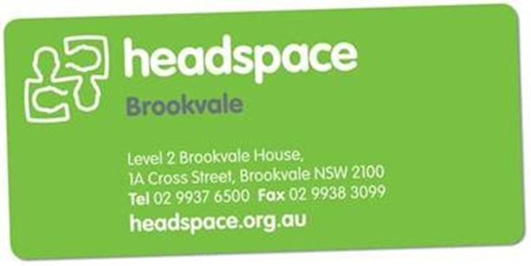
Agencies/Service Provider Referral form
Please form to fax: (02) 99383099 or email to: headspacebrookvale@newhorizons.net.au
Our intake worker may be contacted during business hours on (02) 99376500
Please note that we are not an emergency service or Crisis Service. If you require immediate assistance please call the mental health care line on 1800 011 511. Alternatively, direct your young person to the Emergency Department of their nearest hospital.

All referrals are reviewed at our intake meeting to determine appropriateness for headspace. We will be in touch within 2 business days: to either offer an appointment, to gather more information regarding the nature and purpose of your referral or to discuss other services who may be more appropriate.

Referrer’s details
Name:
Position: |  |  | Date:
Organisation/school:
Email:
Contact no: |  |  | Fax:
Consent
Has the young person consented to referral? (If no, the referral cannot be accepted)  Yes No |  | If the young YP is under 16 years, are the parents/carers aware? (If no, the referral cannot be accepted)  Yes No
Young person’s details
Surname:
Given names:
Preferred name:
Date of birth: |  |  |  |  | Age:
Contact No. |  |  |  | SMS consent: |  |  | Yes No
Email:
Gender: | Male Female Other
Medicare card # |  | Reference #
Home/Living
Street Address: |  | Suburb:
State: |  | Post code:
Where is the YP living: | At home with family/guardian  Shared accommodation  Staying with friends  Living alone  Med-long term supported accommodation  Refuge/crisis accommodation  Other:
Emergency contact
Full Name:
Relationship: |  |  | Consent to be contacted other than in an emergency? Yes No
Contact No.

Current supports and other services involved: (GP, Psychiatrist, FACS etc)

School/TAFE/Uni attending: |  |  |  | Current year or highest level achieved: |  | <Year 10 Year 11  Year 12 Tertiary
 |  |  |  | Employment status:
Is this YP of the following background? | Aboriginal Torres Strait Islander Both Unknown Neither
Country of birth? |  |  | Level of English proficiency: |  | Very well Well Not well Not at all
What culture(s) does YP identify with? (e.g. Chinese, Arabic, Pacific Islander, Australian, New Zealander):

Any special need requirements to be aware of? eg vision impaired, hearing impaired, cognitive impairment

Interpreter required?
Language:

Reason(s) for referral:

Homeless or at risk of homelessness Pregnancy/ Young parent Mental Health
Relationships Family issues School issues Gender/ sexuality Trauma/Domestic Violence Physical/Sexual Health Behavioural concern
Alcohol and drugs (please specify): Work and Education Options
Other (please specify):

Details of issue(s). (Please provide as much detail as possible – include any previous diagnoses, treatment(s), risks and some information about presenting issues)
1. What is the presenting issue/main reason for this referral?

2. Precipitating Factors/ Risk factors?

3. Is the YP at risk of harming themselves or others?

Details of Risk/History of Harm:

4. Are there any other contributing issues of concern?
(e.g. Legal, Family, School, Housing)

5. Has the YP ever received prior mental health care?

Reason for previous care:

Name and contact details of service if known:

Are there any diagnoses, treatments, medications or hospital admissions?
Details:

Office use only
Date of referral:
Appointment:
Referred by/ Referral Method:
Intake clinician:
Attended Headspace before and when?
Mastercare? | Yes No | Spread sheet completed? | Yes No
YP entered into HAPI? | Yes No

