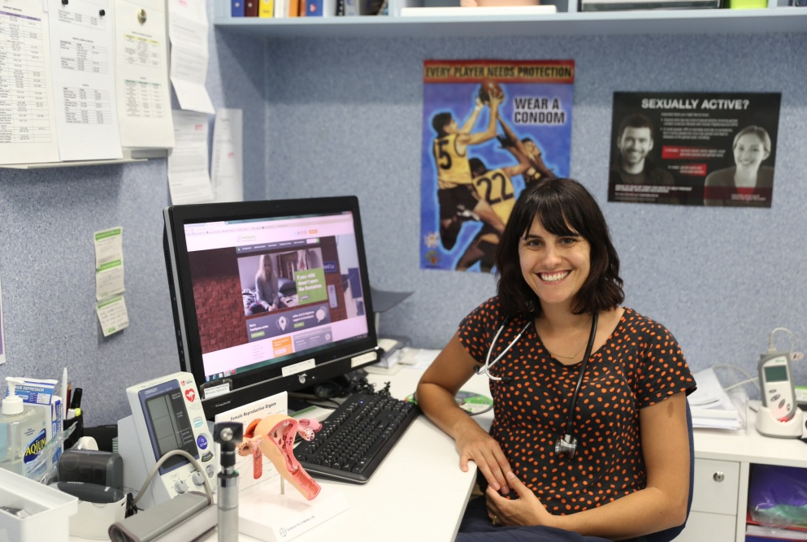

**Dr Melody Miolin**

**What is your role at headspace?**

I am one of the General Practitioners (GPs) at headspace. I see young people for anything they need to see a doctor for – coughs and colds, feeling stressed or down, sexual health testing, contraception, sporting injuries or any other concerns they have!

**Where are you from?**

I was born and grew up in Manjimup, a town quite a bit smaller than Broome, in the South West of Western Australia. It is a place with lots of big trees and cold weather. I moved to Perth when I finished school to go to university and have lived in Broome now for the last four years.

**Where have you been?**

I have been lucky enough to travel a lot overseas including the US, Europe and Asia. I love roadtrips and spending time exploring national parks. Despite the places that I have seen, camping in the beautiful Kimberley is still one of my all-time favourite things, and I do it as often as I can.

**What have you studied?**

I went to high school at Manjimup Senior High, and then to the University of Western Australia to study medicine. Once I completed my medical degree (which was 6 years) I worked as a junior doctor at Royal Perth Hospital before moving to Broome to train as a GP.

**What do you enjoy about what you do?**

I am lucky to have a job that changes every day. I enjoy meeting lots of different young people and learning about them and the things going on in their lives. I like being able to use my medical knowledge to help them stay healthy or get better when they are unwell.