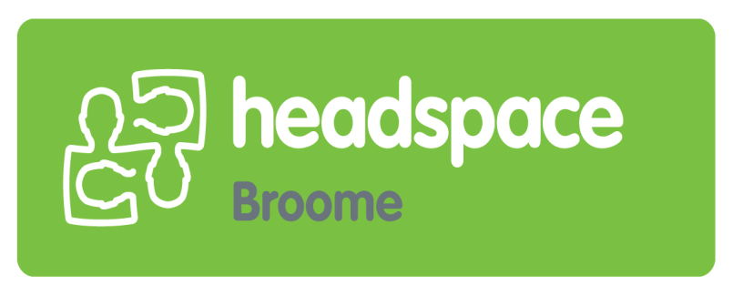

POSITION DESCRIPTION

Job Title: Independent Chair
Remuneration: Voluntary
Benefits include access to headspace National training and networking opportunities.

About headspace Broome
The headspace Broome mission is to promote and facilitate improvements in the mental health, social wellbeing of young people aged 12-25. headspace Broome is a youth friendly Centre that provides services across four core streams; primary health care, mental health, alcohol and other drug (AOD), and vocational services. The clear intention is to significantly increase the number of young people that are identified and responded to with integrated evidence based interventions, at the earliest possible point when problems emerge.

headspace Broome consortium
The headspace Broome Consortium meets to exercise a broad governance and strategic function in order to provide advice to the Centre Manager, Chief Executive Officer and Board of Kimberley Aboriginal Medical Services Ltd (KAMS) on the best way to meet the vision, mission and key objectives of headspace Broome.

Requirements:
The Independent Chair should:
- be passionate about youth health and wellbeing
- have knowledge of the youth and mental health sectors
- have experience chairing and effectively running meetings
- Hold or be willing to obtain a Working with Children’s Check.

Role:
The role requires developing an active consortium that supports the core strategic objectives of the headspace model, provides local context and supports the Centre Manager to manage headspace.

Key Responsibilities:
- Act in the best interest of the headspace program.
- Preside at bi-monthly consortium meetings and ensure that business is conducted efficiently and that meetings are conducted properly.
- In conjunction with the headspace Manager, develop the agenda for the consortium
- Encourage and enable participation of all members and ensure youth advisory members feel heard and welcomed.

How to apply
Expressions of interest can be sent to headspace@kamsc.org.au
Further information can be obtained by contacting Kristen Orazi, headspace Broome Senior Manager on 9193 6222 or via email headspace@kamsc.org.au

