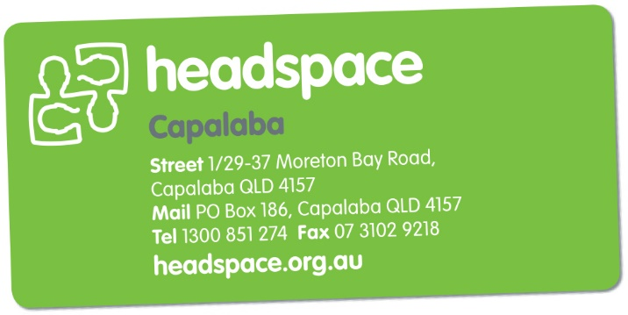

headspace Capalaba Youth Reference Group

Are you aged between 12 and 25 and live in the Redlands area or the bayside/eastern suburbs of Brisbane? Do you have something to say about health, mental health and drug and alcohol issues?

Who can apply?

We are looking for
anyone aged between 16 and 25 who wants to
involved with their local
headspace centre.
We are looking for about 12 local young people to join the group.

We want you to apply if:

you have had your own experiences of feeling depressed, anxious or another mental health issue

you have a friend or family member who has/or had a mental illness or drug addiction,

you feel passionate about and are interested in mental health issues,

The group is also keen to hear the voices of Indigenous young people, young people from different cultural backgrounds, young people from rural and remote areas, gay, lesbian, bisexual and transgender young people and young people who have been homeless.
What is the headspace Capalaba Youth Reference Group?

headspace Capalaba is providing young people with the opportunity to be heard and be active around youth mental health and alcohol and other drug issues. There are a number of roles you can play in a headspace Capalaba Youth Reference Group, including:
- Research and evaluation of headspace services
- Consultation around resource development such as, factsheets, brochures, radio ads etc
- Peer support and mentoring
- Leading a project in your local area
- Website consultation and development

By getting involved you will:
- Have the opportunity to have your say and influence youth mental health services in your area
- Develop new skills
- Meet and work with other young people who are passionate about youth mental health
- Make a difference to youth mental health

headspace Capalaba will provide support you enable you to participate in the above groups or activities

How do I get involved?

Complete the application form and email it to headspace.capalaba@aftercare.com.au
or you can post it to PO Box 186, Capalaba, QLD 4157

headspace Capalaba
Youth Reference Group Application Form
Personal Details
Name
Phone
Email

Address

Date of Birth
Gender

What languages do you speak at home?

Where were you born?

Are you Aboriginal or Torres Strait Islander?

Are you from a rural or remote area?

Do you have a family member with a mental illness?

Do you identify as having/had a mental illness?

Is this something that you would be happy (and feel comfortable) talking about?

About You

Please tell us a bit about yourself?
(For example: I am 15 years old, and attend alternative education centre 3 days a week, I like skate-boarding etc)

Why do you want to be involved in headspace?

Please describe why you are interested in becoming a Youth Reference Group member?

What type of headspace activities would you like to be involved in?

What skills and ideas could you bring to the Youth Reference Group?

Are you involved in any other organisations? If yes, which ones and what is your involvement?

