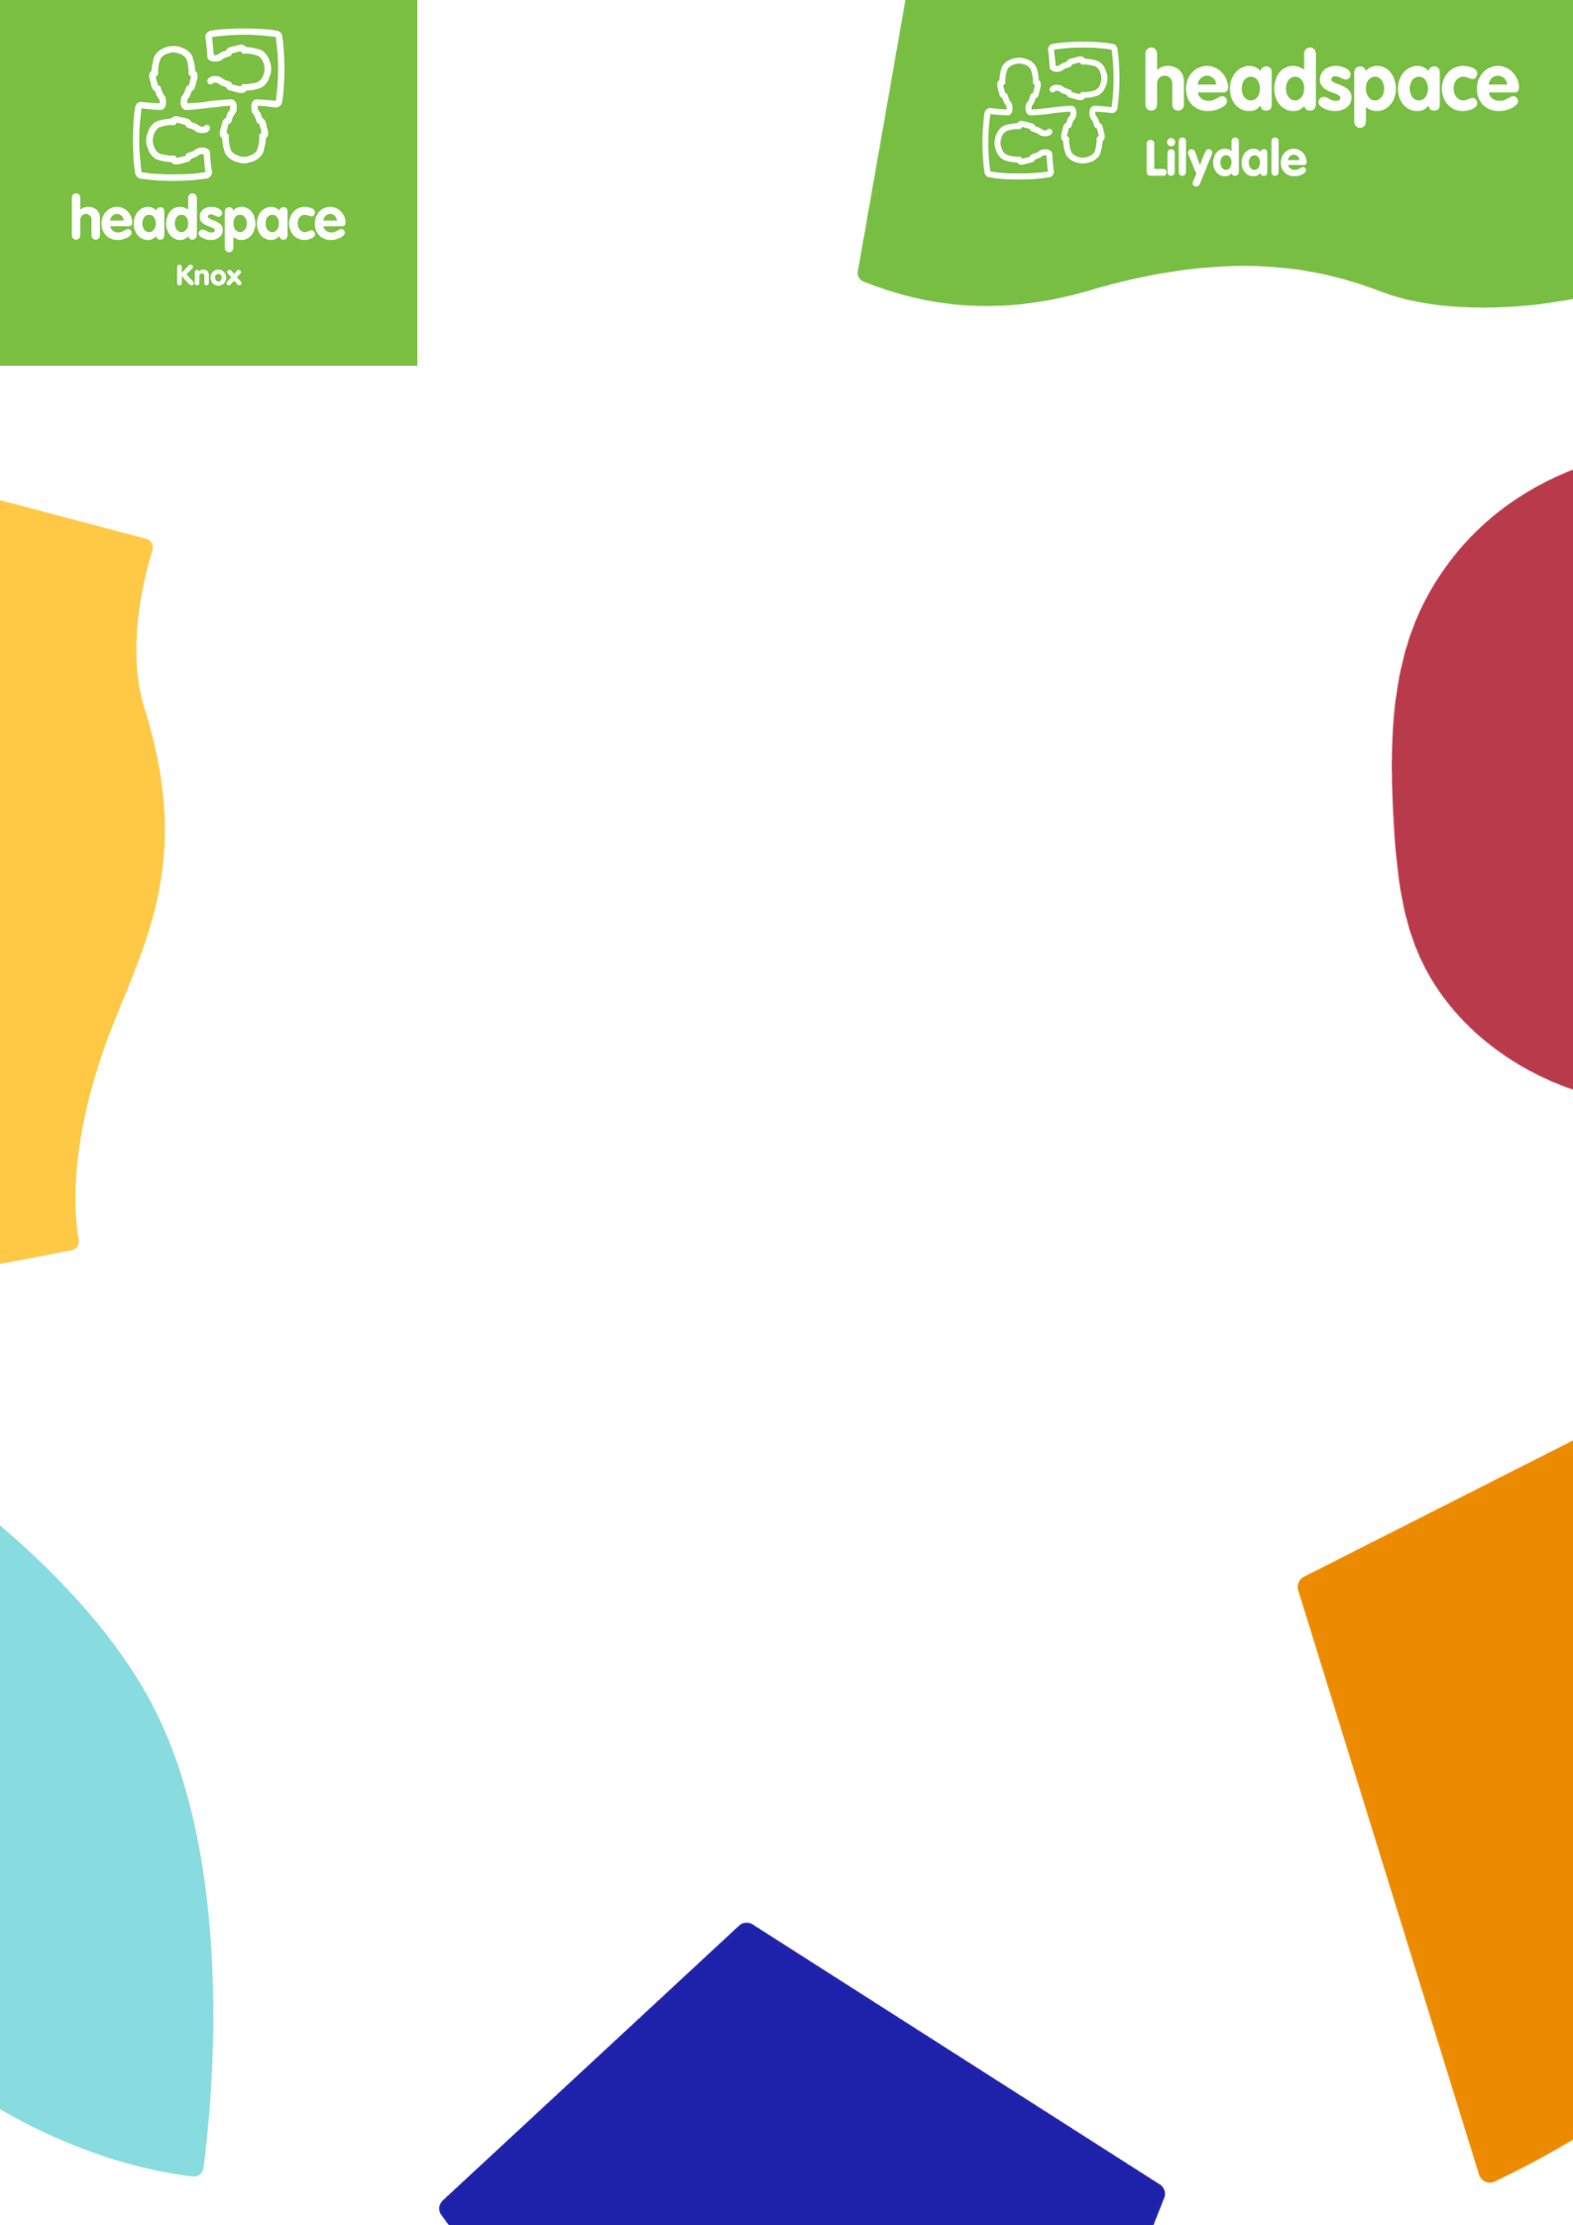

Applications are now open for the:
Headspace Knox Youth Action Force

Are you aged between 16 and 25 and live, work or play in the Knox, Maroondah or Yara Rangers regions? Are you passionate about youth health, mental health and drug and alcohol issues?

What is the headspace Knox Local Youth Action Force?

Headspace Knox is providing young people with the opportunity to be heard and actively participate in community events surrounding youth mental health and alcohol and other drug issues. There are a number of roles you can play in a headspace Knox Youth Action Force, including:
- Leading a project in your local area
- Website and Social Media consultation and development
- Research and evaluation of headspace Knox services
- Consultation around resource development such as, factsheets, brochures, etc
- Peer support and mentoring
- Amplifying the youth voice at headspace Knox
- Smashing mental health stigma in the local community
- Strengthening mental health literacy for young people, their families and your local community
- Representing headspace Knox at a range of community events and presentations

By getting involved you will:
- Have the opportunity to have your say and direct youth mental health services in Australia
- Develop new skills
- Meet and work with other young people who are passionate about youth mental health
- Make a difference to youth mental health in your community

Headspace Knox will provide some training to support you to participate in the above groups or activities

How do I get involved?
Complete the application form and email it to
Caity.Cox @headspaceknox.com.au

Who can apply?

We are looking for
anyone aged between 16 and 25 to be involved in the Youth Action Force.
We have about 10 local young people in the group.

We want you to apply if:

You have had your own experiences of feeling depressed, anxious or with another mental health issue

You have a friend or family member who has/or had a mental illness or has been drug affected

You feel passionate about and are interested in mental health issues

The group is also keen to hear the voices of Indigenous young people, young people from different cultural backgrounds, young people from rural and remote areas, young people that are a part of the LGBTQIA+ community and young people who have been homeless.

Headspace Knox Youth Action Force Application Form:

Name:
Preferred name:
Phone:
Email:

Address:
Date of Birth:
Gender Identity:

What languages do you speak at home?

Where were you born?

Are you Aboriginal or Torres Strait Islander?

Are you from a rural or remote area?

Do you have a family member with a mental illness?

Do you identify as having/had a mental illness?

Is this something that you would be happy and feel comfortable talking about?

About You:

Please tell us a bit about yourself! eg hobbies and interests, if you’re working/studying etc

Please tell us a bit about why you are interested in becoming a Youth Action Force member

What skills and ideas could you bring to the Youth Action Force?

What do you know about headspace already?

Are you involved in any other organisations? If yes, which ones and what is your involvement?

