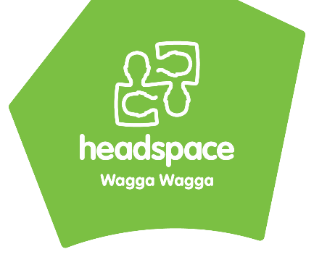

Referral Form

Date: __________________
Young person’s details:

Full Name: _____________________________________________________________________________________________________________

Address: _______________________________________________________________________________________________________________

Postal Address (If different): ___________________________________________________________________________________________

DOB: _______________________ Current Age: ___________ Gender: __________________________________________________

Do you identify as being Aboriginal or Torres Strait Islander? ☐ Yes ☐ No

Phone Number: _______________________________________________________________________________________________________

Email Address: ________________________________________________________________________________________________________
*Please Note; we must have at least two ways that we can contact you

Preferred Contact Person and Phone Number (for appointments only):
________________________________________________________________________________________________________________________

Services I am interested in:

☐Mental Health Support
☐Drug and Alcohol
☐GP
☐Dietician
☐Work and Study Support
☐Other: ____________________________________

Please specify the main reason for seeking help:

Service access information:
Do you have an existing GP? ☐ Yes ☐ No__________________________________________
Do you have an existing MHTP? ☐ Yes ☐ No _________________________________________
Are you linked with any other services? ☐ Yes ☐ No _________________________________________
Do you have an existing counsellor? ☐ Yes ☐ No _________________________________________
Have you accessed any FPS sessions this calendar year? ☐ Yes ☐ No _________________________________________
Do you have a NDIS plan? ☐ Yes ☐ No If yes does it include Psychology? ☐ Yes ☐ No
Risk:
Have you deliberately harmed yourself? ☐ Yes ☐ No
Have you been admitted to the hospital in the last 30 days for Mental Health? ☐ Yes ☐ No
Have you thought of ending your life? ☐ Yes ☐ No
*If yes to any of the above – Mental Health Line must be advised of on 1800 011 511. ☐ Yes ☐ No

Digital Programs recommended – Mindspot ☐ Yes ☐ No BRAVE ☐ Yes ☐ No This Way Up ☐ Yes ☐ No

Referrer’s details:
- ☐Has the young person consented to this referral being made?
- ☐If the young person is under the age of 14, have the person’s parents or carers given consent?

Name: ___________________________________________________________________________________________________________________
Organisation: ___________________________________________________________________________________________________________
Relationship to Client: __________________________________________________________________________________________________
Postal Address: _________________________________________________________________________________________________________
Phone Number: _________________________________________________________________________________________________________
Email Address: __________________________________________________________________________________________________________
*Please Note; we will continue to liaise with the client from this point, unless consent is provided from the client.

How to submit this form:
In Person: Drop into our centre (2/185 Morgan Street, Wagga Wagga)
Free Call: 1800 856 572
Phone: (02) 6937 9000
Fax: (02) 6937 9045
Email: myheadspace@headspacewagga.org.au
Mail: PO BOX 5693, Wagga Wagga BC, NSW 2650

Please note: This service is not a crisis service.
For any immediate concerns please call Mental Health Line on 1800 011 511
This is a 24 hour telephone service,

